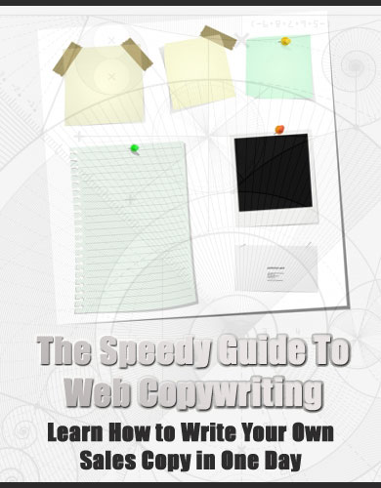

LEGAL NOTICE:

The Publisher has strived to be as accurate and complete as possible in the creation of this report, notwithstanding the fact that he does not warrant or represent at any time that the contents within are accurate due to the rapidly changing nature of the Internet.

While all attempts have been made to verify information provided in this publication, the Publisher assumes no responsibility for errors, omissions, or contrary interpretation of the subject matter herein. Any perceived slights of specific persons, peoples, or organizations are unintentional.

In practical advice books, like anything else in life, there are no guarantees of income made. Readers are cautioned to reply on their own judgment about their individual circumstances to act accordingly.

This book is not intended for use as a source of legal, business, accounting or financial advice. All readers are advised to seek services of competent professionals in legal, business, accounting, and finance field.

You are encouraged to print this book for easy reading.

Table of Contents

Web Copywriting: Essential or Not? 5

How to Mind Map Your Offer and Craft Your Sales Copy Flow 6

The Five Ps of Web Copywriting 7

How to Write a Compelling Headline that Qualifies Your Prospects 9

The Compelling Story Technique 11

Introducing Your Offer and Instilling the Power Benefits 12

Killing All Prospect Doubts - Leave No Chance to Excuse 13

Act Now - Not Later! 15

Real-Life Case Studies of Web Copywriting in Action 17

CONCLUSION: Final Tips and Tricks to Improve Your Sales Piece 20

The Speedy Guide to Web Copywriting
Learn How to Write Your Own Sales Copy in One Day

Web Copywriting: Essential or Not?

One of the things that makes the Internet so appealing is the fact there is plenty of useful and entertaining information to be found. Of course, some website owners prefer to simply copy data from other sources as a way to flesh out the content of their sites.

When this happens, they miss out on some great opportunities. Here are just a couple of reasons why original web copywriting is not only important, but essential to the success of a web site.

Firstly, original copy helps to make the website stand out from the millions of other sites that are already up and running. Even if the subject matter is the same that is found around the Internet, orginal copy is the chance to put the data into word combinations that are a little different. When the content of the site is not a copycat of thousands of similar sites, the chances for ranking higher on searches is much better.

Along with making the site stand out a litle more, creating original copy also makes it possible to use keywords to the best advantage. This can also help to push the ranking up a few more notches in search engines.

Strategically placing keywords that are part of common searches online help to improve the chances of showing up in the top ten results. Higher rankings mean more visitors. If the purpose of the site is to market an idea or product, this is a very good thing.
Lastly, copywriting provides a creative outlet. Drafting original content makes it possible to show the world what you have to offer in the way of ideas, style, concepts and opinions. You simply can’t do that if the content is borrowed from another source.

While it is true that coming up with original content takes longer than simply cutting and pasting canned content onto the site, the benefits far outweigh the time spend in the endeavor. When given a choice between going with tired old copy that can be found all over the Internet and coming up with something new and different, always go for the fresh web copy.

How to Mind Map Your Offer and Craft Your Sales Copy Flow

Mind mapping is a valuable tool when it comes to creativing effective sales copy. While not everyone is familiar with the concept of a mind map, chances are you have seen the approach used to great effect.

Essentially, mind mapping is the presentation of a collection of ideas, concepts, or words that all relate to some type of central understanding. When it comes to applying this approach to the flow of your sales copy, mind mapping can provide some interesting and unique ways to identify benefits of your product that will attract the right consumer market. Here are some ideas of how to use the mind mapping approach.

- Identify your central understanding. In this case, that would be your product offering. This will serve as the point of destination that all other attributes will map back to. Keeping your product as the central focus will make it harder to drift during the course of identifying elements for your sales copy.

- Use single word designations to identify the main functions of your products. This broadens on the central theme, but is still vague enough to allow for more investigation.

- Take it one level deeper. Within the context of those broad themes or ideas, provide examples of how your product benefits work. For instance, if you are selling a carpet cleaner, one broad theme may be the deep foam action. Drilling a little deeper, you can also note the foam lifts dirt easily from both carpet and furniture upholstery.

By mind mapping, you are not only helping yourself to visualize the flow of the text, but also using words to create images for the reader that he or she can easily relate to. Try this method and see what new and different angles you come up with to demonstrate the effectiveness of your product.

The Five Ps of Web Copywriting

When settling in to draft original copy for a web project, it is important to keep the five Ps of Web Copyrighting in mind. In fact, using this simple formula will make all the difference in how well you stay on track with your objectives.

Here are each of the five Ps along with a simple definition.

- Problem – Whenever your task is to convince someone of a need, you must first convince the buyer there is a dilemma that must be addressed. This dilemma or problem helps to set up a sense of urgency, indicating action must be taken in order to take care of the issue at hand. Once your copy presents this problem, then you can begin the process of convincing the buyer you have the solution.

- Promise – Essentially, your promise is that the subject matter of your sales pitch is going to make everything okay again. For example, if you presented the problem of dirty windows, you now promise that your product provides the best solution available.

- Proof – Having made a promise or claim, it is now time to put your money where your mouth is. In order words, you are going to present all the reasons why your solution works better than anything else. Here is where you make your solution irresistible to the consumer by pointing out how quickly and easily the problem can be made to go away.

- Price – After making all the benefits clear, you add the icing to the cake. That is, you make note of what a small cost is necessary to obtain all these wonderful advantages. The idea is to convey that your solution is worth every penny of the cost, even if it may be a little more than some of the similar but obviously inferior products offered by the competition.

- P.S. – This is where you add in one more added benefit. This can be something that is outside the scope of the original problem, but somehow still related. For example, you may note that your product not only makes windowpanes crystal clear, but will also do a great job on that resin furniture in the back yard. The p.s. is your chance to provide one more benefit and thus nudge a consumer who is on the fence to go ahead and take the plunge.

This simple formula can be utilized with just about any type of situation where you want to present an issue and then offer a viable solution. Give it a try. Think of a single problem and then see where this process takes you. The results will be a pleasant surprise.

How to Write a Compelling Headline that Qualifies Your Prospects

No matter how well crafted the body of your content, a headline that grabs attention will always make a difference. Of course, you want to grab the right kind of attention. That is, you want the reader to be attracted by the headline and thus want to read the body of the text.

You do not want the reader to read the text simply because he or she wants to find out what type maniac would come up with a title like that. Here are three simple tips to keep your headlines interesting, compelling, and attractive to your audience.

Tip # 1 – Keep it simple, stupid. Yes, the old KISS principle that Toastmasters have used in public speaking for decades also works with the printed word. When it comes to your headline, don’t get too prolific with the word count. Choose your words carefully and use no more than you need to grab attention. A headline is not meant to tell the whole story, but it should help your prospect know what is coming next. is to come.

Tip # 2 – Make it relevant. Headlines that are misleading may grab attention quickly, but you will lose the reader in just a few seconds if the content has nothing to do with the promises made in bold. It is okay to use double entrendes or other plays on words with your headline. Just make sure that by the time your readership has made it through the first paragraph, they get the relationship.

Tip # 3 – Make the headline memorable. You want people to recommend the content to other people. If the headline is so bland that it really doesn’t stick with the reader, then you will lose a lot of attention. While you want simplicity and relevance, you do not want boring. Make the headline zippy and something people will want to repeat.

Headlines are often overlooked as being unimportant or just a formulaic construct of writing copy. Neither concept is true. Headlines are essentials and can play a huge role in grabbing attention. When coupled with compelling copy, a great headline can make all the difference between success and failure.

The Compelling Story Technique

Any successful copy is going to tell a story. Just how well that story is told makes all the difference in whether or not a prospect turns into a customer. Here are a few tips to help you tell your story in a way that will hold the attention of the prospect and keep it all the way through to the close of the sale.

First, set the stage for your story. The idea is to grab the interest of the reader by presenting a situation that he or she can relate to. Ideally, the situation will form the basis for your story by creating a conflict that must be resolved. The more your prospect can identify with the conflict, the better your chances of enticing him or her to keep reading.

Next, offer the ideal solution for taking care of the conflict. In a sense, this is your shining knight that comes over the horizon to save the day. This is your chance to work in all the good qualities that make your solution the perfect way to deal with the conflict and thus restore order to the kingdom, which is the life of your prospect. Use this element to start building confidence that the solution really will work.

Third, demonstrate how the solution does in fact resolve the conflict. You can use case studies, testimonials, or a number of other devices to back up the claims you previously made. Again, make sure this proof is reasonable and will appeal to your audience in a way that helps them to envision using the product or service themselves.

Last, go for the sale. Inspire in the prospect a burning desire to possess this product by recapping all the great things it will do, and also note how reasonable the cost will be. Imagine, heaven can be had for such a low price! Once you have established this sense of urgency to own in your prospects, they will quickly become loyal customers who will gladly share your good name far and wide.

Introducing Your Offer and Instilling the Power Benefits

In general, your sales copy has only a few seconds to grab the interest of a prospect and move them along to closing the sale. That means you have to provide a quality introduction to what you have to offer and follow it up with all the reasons why your product should be chosen above all others. Here are some simple ideas on how to introduce your offer and quickly instill a sense of urgency about those power benefits.

First, don’t spend a lot of time on fancy words. Write the copy just as if you were speaking to the consumer in person. This will help you to avoid using too many words, and especially to stay away from using too many technical terms that could turn off your prospect before you ever grab their initial interest. Essentially, you are letting the consumer know they have a problem and you have a solution.

Next, get into the meat of that solution. Point out the main benefits of the product in question. Relate those benefits to common situations that come along with the problem. Illustrate how those benefits quickly and easily remove obstacles and restore order to a chaotic set of circumstances. Driving home how problems get solved quickly and easily will help to sustain interest.

Third, toss in some added power benefits. These can be anything from pointing out the time saved can be used for more enjoyable tasks to noting how the product helps to cut down on related expenses. These value add talking points will help to demonstrate that the product is truly indispensible, and make it even more attractive.

Last, recap the benefits. You can use a summary format for this, perhaps even a bulleted list. This helps to reinforce the benefits in the mind of the reader and prepare him or her for the close of the sale.

Using this technique will make a huge difference in the way your prospect responds to your product, and how quickly you can move on to closing the sale.

Killing All Prospect Doubts - Leave No Chance to Excuse

Up to this point, you have done a great job. Your presentation of the problem was ideal. Your followup with the benefits and proof of how efficient and valuable your product was great. You even thought the close statement was right on the mark.

So why is the prospect still hesitating?

Consumers always have objections. It is a fact of life. It is also a fact that you overcame some of them in your copy already. What remains is to address the remainder of them and thus remove all obstacles to the final sale. Here’s what you need to do.

- Give bonuses – In other words, provide added value to the benefits already listed. These may be more specific, whereas the earlier content was broad.

- Give long period of money back guarantee – This will often hook in many consumers who are sitting on the fence. If you are willing to provide a six month money back guarantee where the competition offers thirty days only, you build a lot of confidence and credibility with the prospect.

- Give FAQ to answer common questions – This is your chance to get specific. You may even use questions that have come up in the past through discussions with established customers or general queries that came in to your website. Reading through the Frequently Asked Questions page can make a huge difference for your prospect.

- Offer trial for monthly memberships – this may be a short trial membership that is free for the first month, or one that is deeply discounted. This will depend a lot on your target niche markets, but keep in mind that people usually are suspicious of something that is given away for nothing. A discounted introductory rate might be just the ticket.

- Show testimonials from experts – People like to know that some type of expert thinks the product is a good choice. Your experts may be professionals who use the product, or even researchers who can point out some of the more attractive characteristics of the product.

- If it’s software, give a demo – A quick and partial test run can alleviate fears that the product may be too complicated for the prospect to figure out. Calm those fear with a test drive that shows just how user friendly the product really is.

Act Now - Not Later!

One of the goals you have for your sales copy is to compel the reader to make a decision now. All too often, copy builds an excellent case for considering the product, but does not follow through with that little added extra that pushes the prospect off the fence and into making a decision to buy. Here are a three basic ways to make sure your prospect does not get away, and becomes a devoted customer.

First, don’t assume that your prospect remembers all those great advantages you so painstakingly mentioned earlier in your copy. Instead, do a quick recap. The recap does not have to be an exhaustive replay of all those benefits. In fact, something as simple as a quick bulleted list will often do the trick. This simple device makes it possible for the reader to see the benefits one more time without having to scroll backward to review them.

Next, don’t forget those ancillary values that your product provides. It can be anything from easily installation and storage to working well in another common but less likely setting. The idea is to convey the fact that the product is versatile and there is a good chance it will take the place of more than one product the prospect is currently using. That usually sets very well with consumers who want to get the most for their money.

Last, offer something that must be taken advantage of right now, such as a limited time offer of a discount on first purchase, or free support for a month. Everybody likes to get something a little extra when buying a product.

How many times have you noticed toothpaste manufacturers enticing people to try a new brand with by including a free travel size tube along with the main product? You can do the same thing as part of your copy presentation.

Getting consumers to buy now rather than later is to your advantage. The sooner someone buys and actually uses the product, the sooner you can look forward to having one more satisfied customer who will provide good word of mouth. Try out these approaches and see how much good they do for you.

Real-Life Case Studies of Web Copywriting in Action

If you have any doubts about what effective web copywriting can do or want some examples of how copywriting works in a real time situation, it is time to do some searching on the Internet.

Here are some links to sites that will provide you with some excellent background on web copywriting in action, along with a synopsis of what you will find if you follow each link:

- PLRGold: Enterprise – this site will provide you with some excellent ideas on how to lay out the text, as well as how to create an opening that immediately grabs the attention of the reader. This site loads easily for consumers who are using dialup connections. Given the fact that millions of consumers do still use dialup, this can be important, depending on the consumer markets you are targeting.

Link: http://www.privatelabelrightsgold.com/

- The IMGuerilla Everything-In-One Platform - Note the different colors and fonts that help the piece to move along and keep the eye entertained. Also note the frequent opportunities to move on and purchase the product without having to read any further. The eye-catching header is also a nice touch.

Link: http://www.imguerilla.com/

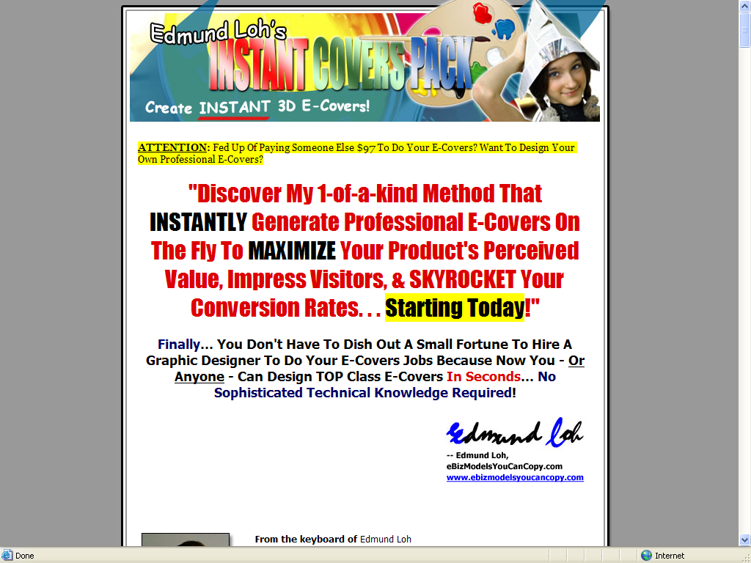

- The Instant Covers Pack – Starting off with a question at the top of the page, this copywriting job grabs the interest immediately by implying that covers can be done quicker, cheaper, and with greater ease. Just like the last two examples, this copy also offers frequent opportunities to move on and purchase the product.

Link: http://www.ebizmodelsyoucancopy.com/icp

- Resell Rights Mastery – This site employs the strategy of presenting the solution in big bold text right at the top of the copy. The reader is easily compelled to find out more about how this great solution works.

Link: http://www.resellrightsmastery.com/

- Cash1234dotcom – This site makes it clear there are ways to make a good weekly income without doing a lot of stuff many people say is essential. This idea grabs attention easily. Note the text color and fonts, as well as the graphics.

Link: http://www.cash1234dotcom.com/

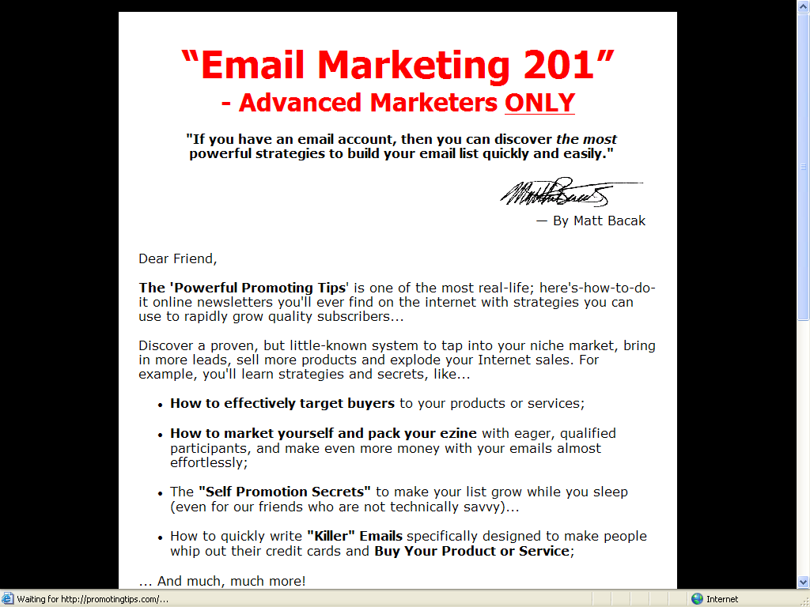

- Promoting Tips – This one is touted as being for advanced marketers, but at the same time implies that the process is easy. Note the quick and easy signup process.

Link: http://www.promotingtips.com/index17.php

Look around the Internet for some other examples. You can pick up some great ideas for your own copy by seeing what others are doing.

CONCLUSION: Final Tips and Tricks to Improve Your Sales Piece

One thing to keep in mind is there is no such thing as a perfect sales copy. There is excellent sales copy that works perfectly today, but there are no guarantees that it will be just as effective a month from now, or even next week. The fact is that sales copy has a relatively short shelf life.

Of course, there are a few ways you can enhance the effectiveness of your copy and thus extend that life for a bit. Here are some ideas:

- Add video – Make your text come alive with video presentations that include slides, animation, and live action sequences. These can be positioned toward the end of the piece, or strategic points along the way.

- Add photos – If video seems like a bit much, then come up with photographs that will help to drive home key points in the flow of the text. These add a bit of visual spice. Best of all, you can change them out with relative ease, and give the appearance of your content a fresh look from time to time.

- Use new fonts. This is so simple that many people overlook it. You can give your text and the entire web page a fresh look simply by making some changes in the font styles and sizes from time to time. Just make sure your choices leave the text easy to read.

- Make use Google AdWords to best advantage. This means inserting logical keywords in order to drive traffic to the site. Also make use of the feature the website optimizer to do split testing for different headlines, different fonts, etc. and see how they play with a live audience.

- Rework a paragraph here or there. You do not have to completely rewrite the text in order to make it fresh. Changing some wording here and there gives you the chance to add fresh keywords, and also reorders the flow of the text to give it a new feel.

Basically, always be on the lookout for some way to make a good thing better. Consumer tastes and demands change from time to time. With the right touch, you can anticipate those trends and use your copy to stay one step ahead of your competition.

